**Cryptography (BITS F463 )**

**Term Project**

*Weightage 25%*

**1 Introduction**

There has been a lot of buzz around blockchains in recent years, ever since Bitcoin became popular. Blockchain technology offers new tools for authentication and authorization in the digital world that preclude the need for many centralized administrators. The scope of this project is to help you get accustomed to blockchain development. You are required to identify one problem that you feel can be solved with the help of blockchain and then implement your solution. You can work in teams which you have already formed earlier.

**2.1 Blockchain Fundamentals**

A blockchain is a digital and distributed ledger of transactions, recorded and replicated in real-time across a network of computers or nodes. Every transaction must be cryptographically validated via a consensus mechanism executed by the nodes before being permanently added as a new “block” at the end of the “chain.” There is no need for a central authority to approve the transaction, which is why blockchain is sometimes referred to as a peer-to-peer trustless mechanism.

Blockchain can be thought of as a linked list with each node containing multiple transactions. Each transaction has a hash that depends on the previous transactions hash as well. So we can see that the order of transactions is important. If we were to change one transaction somewhere, it would have a ripple effect and change the hash of all subsequent transactions. This is one of the reasons why blockchain is a powerful medium for storing transactions.

The placing of a transaction in a block is called a successful conclusion to a proof of work challenge, and is carried out by special nodes called miners. Proof of Work is a system that requires some work from the service requester, usually meaning processing time by a computer. Producing a proof of work is a random process with low probability, so normally a lot of trial and error is required for a valid proof of work to be generated. When it comes to Bitcoins, hash is what serves as a proof of work. Miners on a Blockchain are nodes that produce blocks by solving proof of work problems. If a miner produces a block that is approved by an electronic consensus of nodes then the miner is rewarded with coins. This essentially is the crux of blockchain. Proof of Work is what is keeping all transactions on the blockchain secure and protecting it from malicious attempts to alter these transactions.

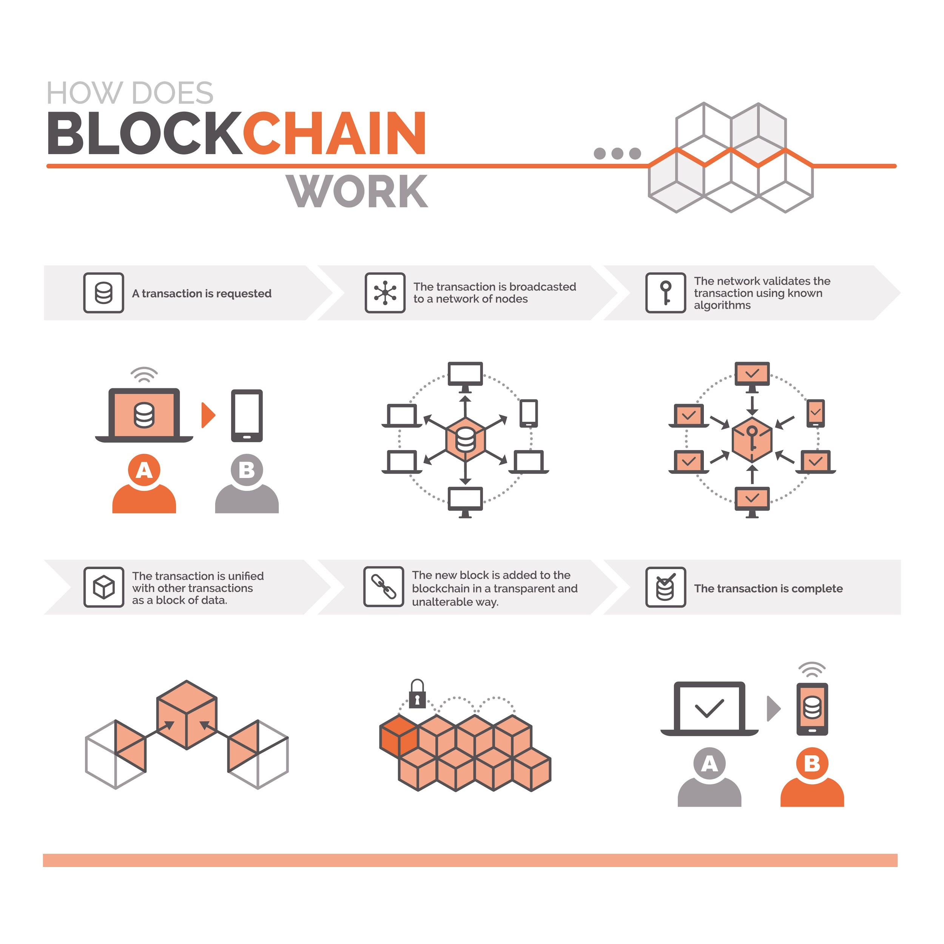

This is just a high level introduction. You are expected to dig deep and understand how the blockchain truly works. Different applications might implement it differently, but the core ideas remain the same.

**2.2 Quick Introduction to Zero-Knowledge Proofs**

Zero-Knowledge Proofs (ZKP) refer to a proof construction that allows you to convince someone that you know something without revealing any information about what it is you know in the process. To explain ZKPs with the help of an example consider the following scenario:

**Scenario:**  
Imagine two friends, Alice & Bob. Bob is color-blind. Alice has two identical balls that only differ in color: red and green. To Bob they seem completely identical and he is skeptical that they are actually distinguishable. Alice wants to prove to him they are in fact differently-colored, but nothing else, thus he does not reveal which one is red and which is green.

Alice gives the two balls to Bob and he hides it. Next, he takes out one ball and displays it. After that he hides the ball again and shows a ball. There is a 50% probability that he switched the balls. Alice is asked if the ball was switched. She could guess and answer correctly with a probability of 50% but if this exercise is repeated multiple times, we can see that this probability will eventually become negligible. So with 5 rounds, he will have a 1 in 32 chance of successfully faking. With 10 rounds, it is 1 in 1024, and with 20 rounds, it is about one in a million. This way one can reach any probabilistic level of proof that is desired, although an absolute certainty can never be achieved.

The above proof is zero-knowledge because Bob never learns which ball is green and which is red; but he can indeed verify that the balls differ in color.

As part of the assignment you will have to implement a similar proof when handling operations on data that you feel should remain secure (example your Aadhar Number when doing some sort of authentication). An algorithm for the same is outlined below.

Alice has sensitive data for which she chooses two numbers and . can be a large prime and is a generator for the meaning of these terms will be covered as the course progresses. For now you can assume ). She calculatesas . Now she performs the following steps to create a zero knowledge proof for .

1. Alice chooses a random number and sends it to Bob as   
2. Bob receives and sends back a random bit (could be 0/1).  
3. Alice sends to Bob.  
4. Bob computes which should equal

Here Bob acts as a verifier and checks if Alice knows the value of without actually getting to know what is. You will have to implement the same in your blockchain application. While implementing the proof it will be up to you to decide on the number of rounds this should go on for.

**3. Deliverables**

1. A brief presentation on the problem that you have identified and how it can be solved through the use of blockchain. Register your team and topic via the google sheet shared already. The presentation should also include details of all team members. The deadline for the same is 11:59 PM 13th April,2022.

2. You are free to code in any language but your solution must implement the following methods:

-- createBlock()  
 -- verifyTransaction()  
 -- mineBlock() or something equivalent for proof of work  
 -- viewUser()

3. All transactions must be verified before they can be added to a block. As part of the verification process, you are required to use a zero-knowledge proof (as described in section 2.2) to verify at least one attribute.

4. viewUser() should list all (successful) transactions against the user.

5. For your final submission, submit your source code & readme as a single .zip or .tar file [here](https://drive.google.com/drive/folders/1piyCbJOmib8S39pFz6cMX71PoXznD_80?usp=sharing). Please name your file as bitsf463_team99 (assuming your team number is 99. You can find your team number from the google sheet you filled earlier). The readme should contain a brief explanation of the project, steps to run the code, and the list of team members. The deadline for the same will be 11:59 PM 25th April 2022. The exact date and demo schedule will be intimated later.

Team Registration Link -[BITSF463_Team_TP.xlsx](https://docs.google.com/spreadsheets/d/1UFdll84VxcE9rjNSrIqxHpWM0BlJ5E3g/edit?usp=sharing&ouid=112605197817799629339&rtpof=true&sd=true)

Final Submission Link - [BITS F463 Assignment 2](https://drive.google.com/drive/folders/1piyCbJOmib8S39pFz6cMX71PoXznD_80?usp=sharing)

**4. Further Reading**  
  
-- [What A Blockchain Actually Is, Written In Blockchain](https://cryptobriefing.com/explain-blockchain-parents/)

-- [Bitcoin White Paper](https://bitcoin.org/bitcoin.pdf)

-- [How Do Bitcoin Transactions Work?](https://www.coindesk.com/information/how-do-bitcoin-transactions-work)

-- [WTF is The Blockchain](https://hackernoon.com/wtf-is-the-blockchain-1da89ba19348)

-- [Creating Your First Blockchain](https://medium.com/programmers-blockchain/create-simple-blockchain-java-tutorial-from-scratch-6eeed3cb03fa)

-- [Zero Knowledge Proofs](https://medium.com/coinmonks/zero-knowledge-proofs-1f4bd8f20d8d)

-- [Zero Knowledge Proofs using Discrete Log](https://people.eecs.berkeley.edu/~jfc/cs174/lecs/lec24/lec24.pdf)

-- [Lectures & Slides on Cryptocurrency from Princeton](https://piazza.com/princeton/spring2015/btctech/resources)